一、安裝軟體
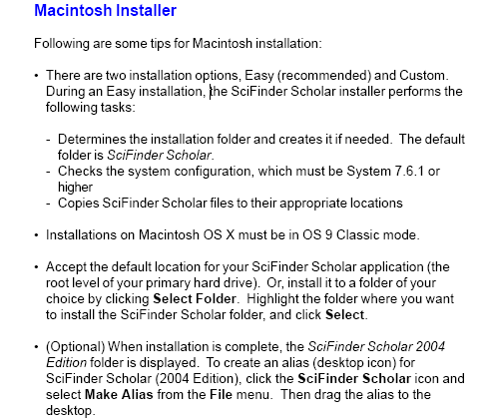

二、設定帳號密碼

1. Click the Scifinder Scholar application or Alias to select.
2. Press and hold the <Control> and <Command (Apple)> keys.
3. Double-click the SciFinder Scholar icon.
4. Release the keys when the Options dialog opens.
5. Type spedit in the Options dialog box.
6. Click OK.

Enter and confirm the password shown as below and click on the “OK” button.
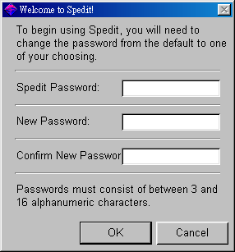
請輸入: spedit Enter: spedit

請輸入: NCKU Enter: NCKU
請輸入: NCKU Enter: NNCKU
(務必輸入大寫字母CAPTIAL)

Select “Scholar Login”, enter the data as appropriate, and then click on the “OK” button.
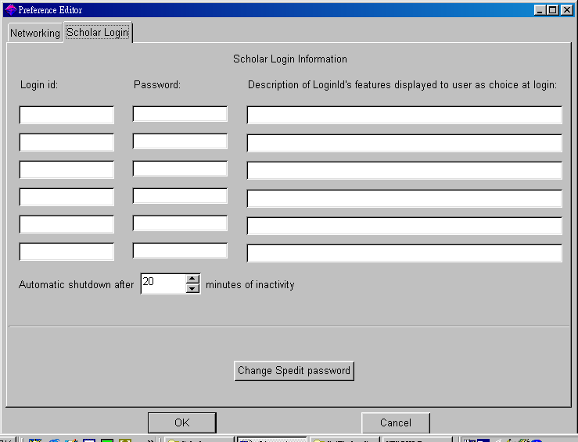
① ② ③
注意!!
請在①輸入：SFSSN153
②輸入：047Z117
③輸入：ncku或是您電腦的 IP位址
Note:
Please enter “SFSSN153” on ①, “047Z117” on ②, and your IP address or nckuon ③

